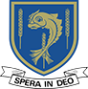
LALEHAM LEA
A Catholic Independent Primary School for boys and girls aged 3 to 11
17th September 2019 For immediate release

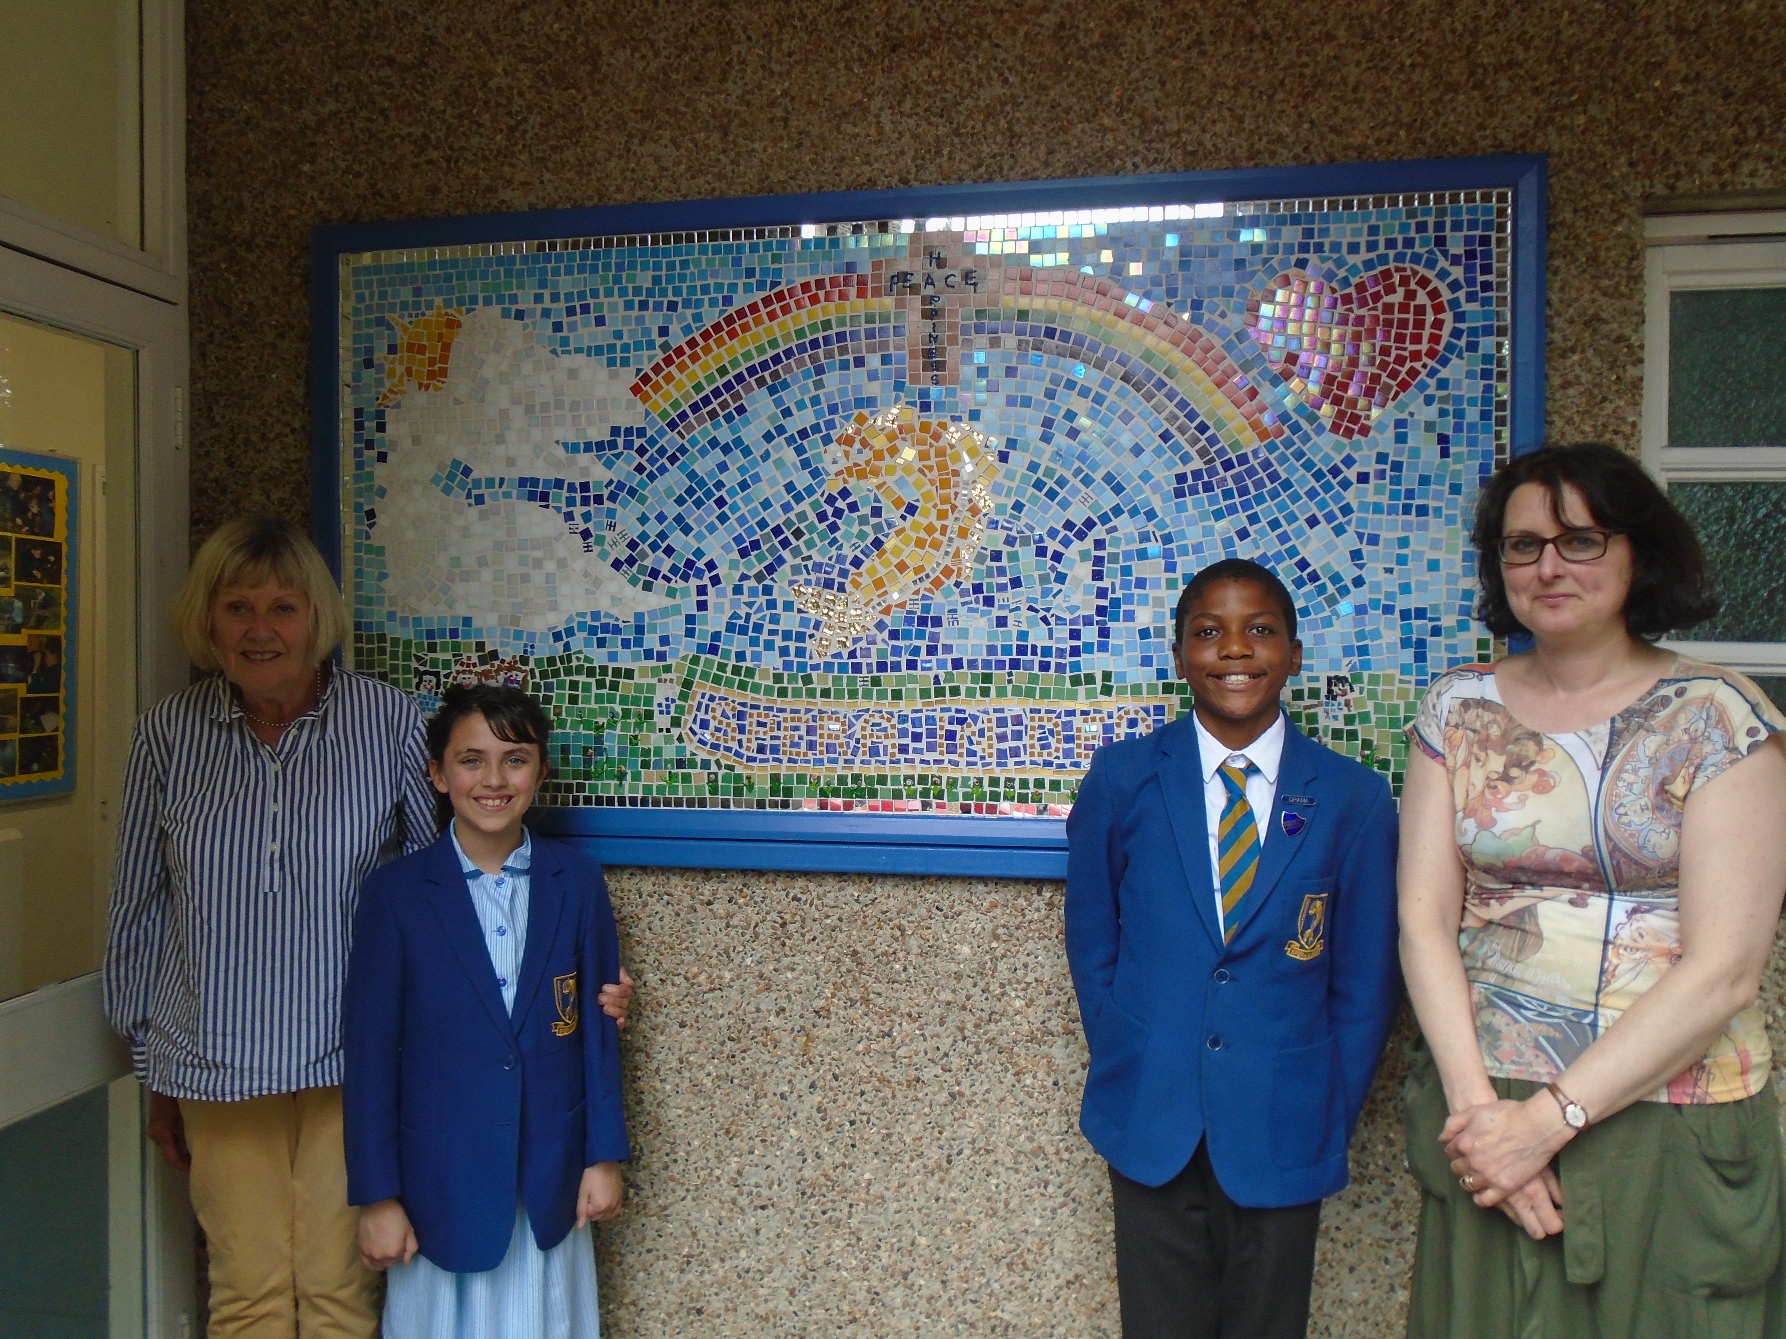

Laleham Lea School Works with Local Arts Society to Create Beautiful Mosaic
Laleham Lea School in Purley has unveiled a beautiful mosaic depicting life at the school created by its Students.
Supported by funding from The Arts’ Society – Croydon Area, the colourful mosaic is located at the Student Entrance to the school and was designed and created by Students from Year 1 to Year 6.
Laleham Lea School was approached by The Arts’ Society – Croydon Area, who support the Arts in local schools by making grants available for the children to be creative, to work on the project and the striking mosaic was many months in the making.
Ms Barry, Head teacher at Laleham Lea said: “We are delighted with the mosaic which our Students worked very hard to create in their Art lessons and Art Club.
“This stunning piece of art will welcome families to our school for many years to come. Our thanks go to The Arts’ Society – Croydon Area and to Mrs De Cintra our Art Teacher who led the project and helped the Students to create this masterpiece.”
Janice Brunger from The Arts’ Society – Croydon Area said: “I visited the school at the beginning of the summer term and on a number of occasions during the term to see how the project was progressing.
“I was always met with smiling children’s faces who seemed to be enjoying cutting pieces of mosaic, gluing the mosaic, sticking them on to the board and gradually seeing their design fulfilled. At the end of the term I was pleased to see at the unveiling of the finished project what I thought was a very good piece of work.
“I must congratulate the Art Teacher, Alicia de Cintra, for the amount of time she spent on the initial design, ordering the materials to be used, supervision of the children involved in the project and adding the finishing touches to the final work.
“I hope that the mosaic will be seen by people entering the school and encourage others to take up Art. Art, in its many forms, is something that can be appreciated by young or old, but if it is not seen it cannot be appreciated.”
ENDS
For more information or images please contact:
Carly Edwards
Laleham Lea School
29 Peaks Hill
Purley
CR8 3JJ
secretary@lalehamlea.co.uk
Tel:0208 660 3351

About Laleham Lea School
Laleham Lea is a Catholic Independent Primary School situated in Purley, Surrey providing education for boys and girls aged 3 to 11 years. The school aims to provide a broad, balanced and challenging curriculum within a happy learning environment. The majority of pupils are Catholic, but we warmly welcome children of all faiths who are sympathetic to our ethos.
For admissions enquiries, please contact: 0208 660 3351.

About The Arts’ Society
The Arts Society is a leading arts education charity with a global network of 385 local Societies, which bring people together through a shared curiosity for the arts. Its events provide welcoming places – locally, nationally and globally – for everyone to hear expert lecturers share their specialist knowledge about the arts. With 90,000+ members who contribute to and preserve our artistic heritage through volunteering and grants, The Arts Society works to create a better, healthier and more connected society. www.theartssociety.org

