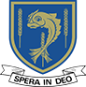
LALEHAM LEA
A Catholic Independent Primary School for boys and girls aged 3 to 11
October 18th 2019
For immediate release
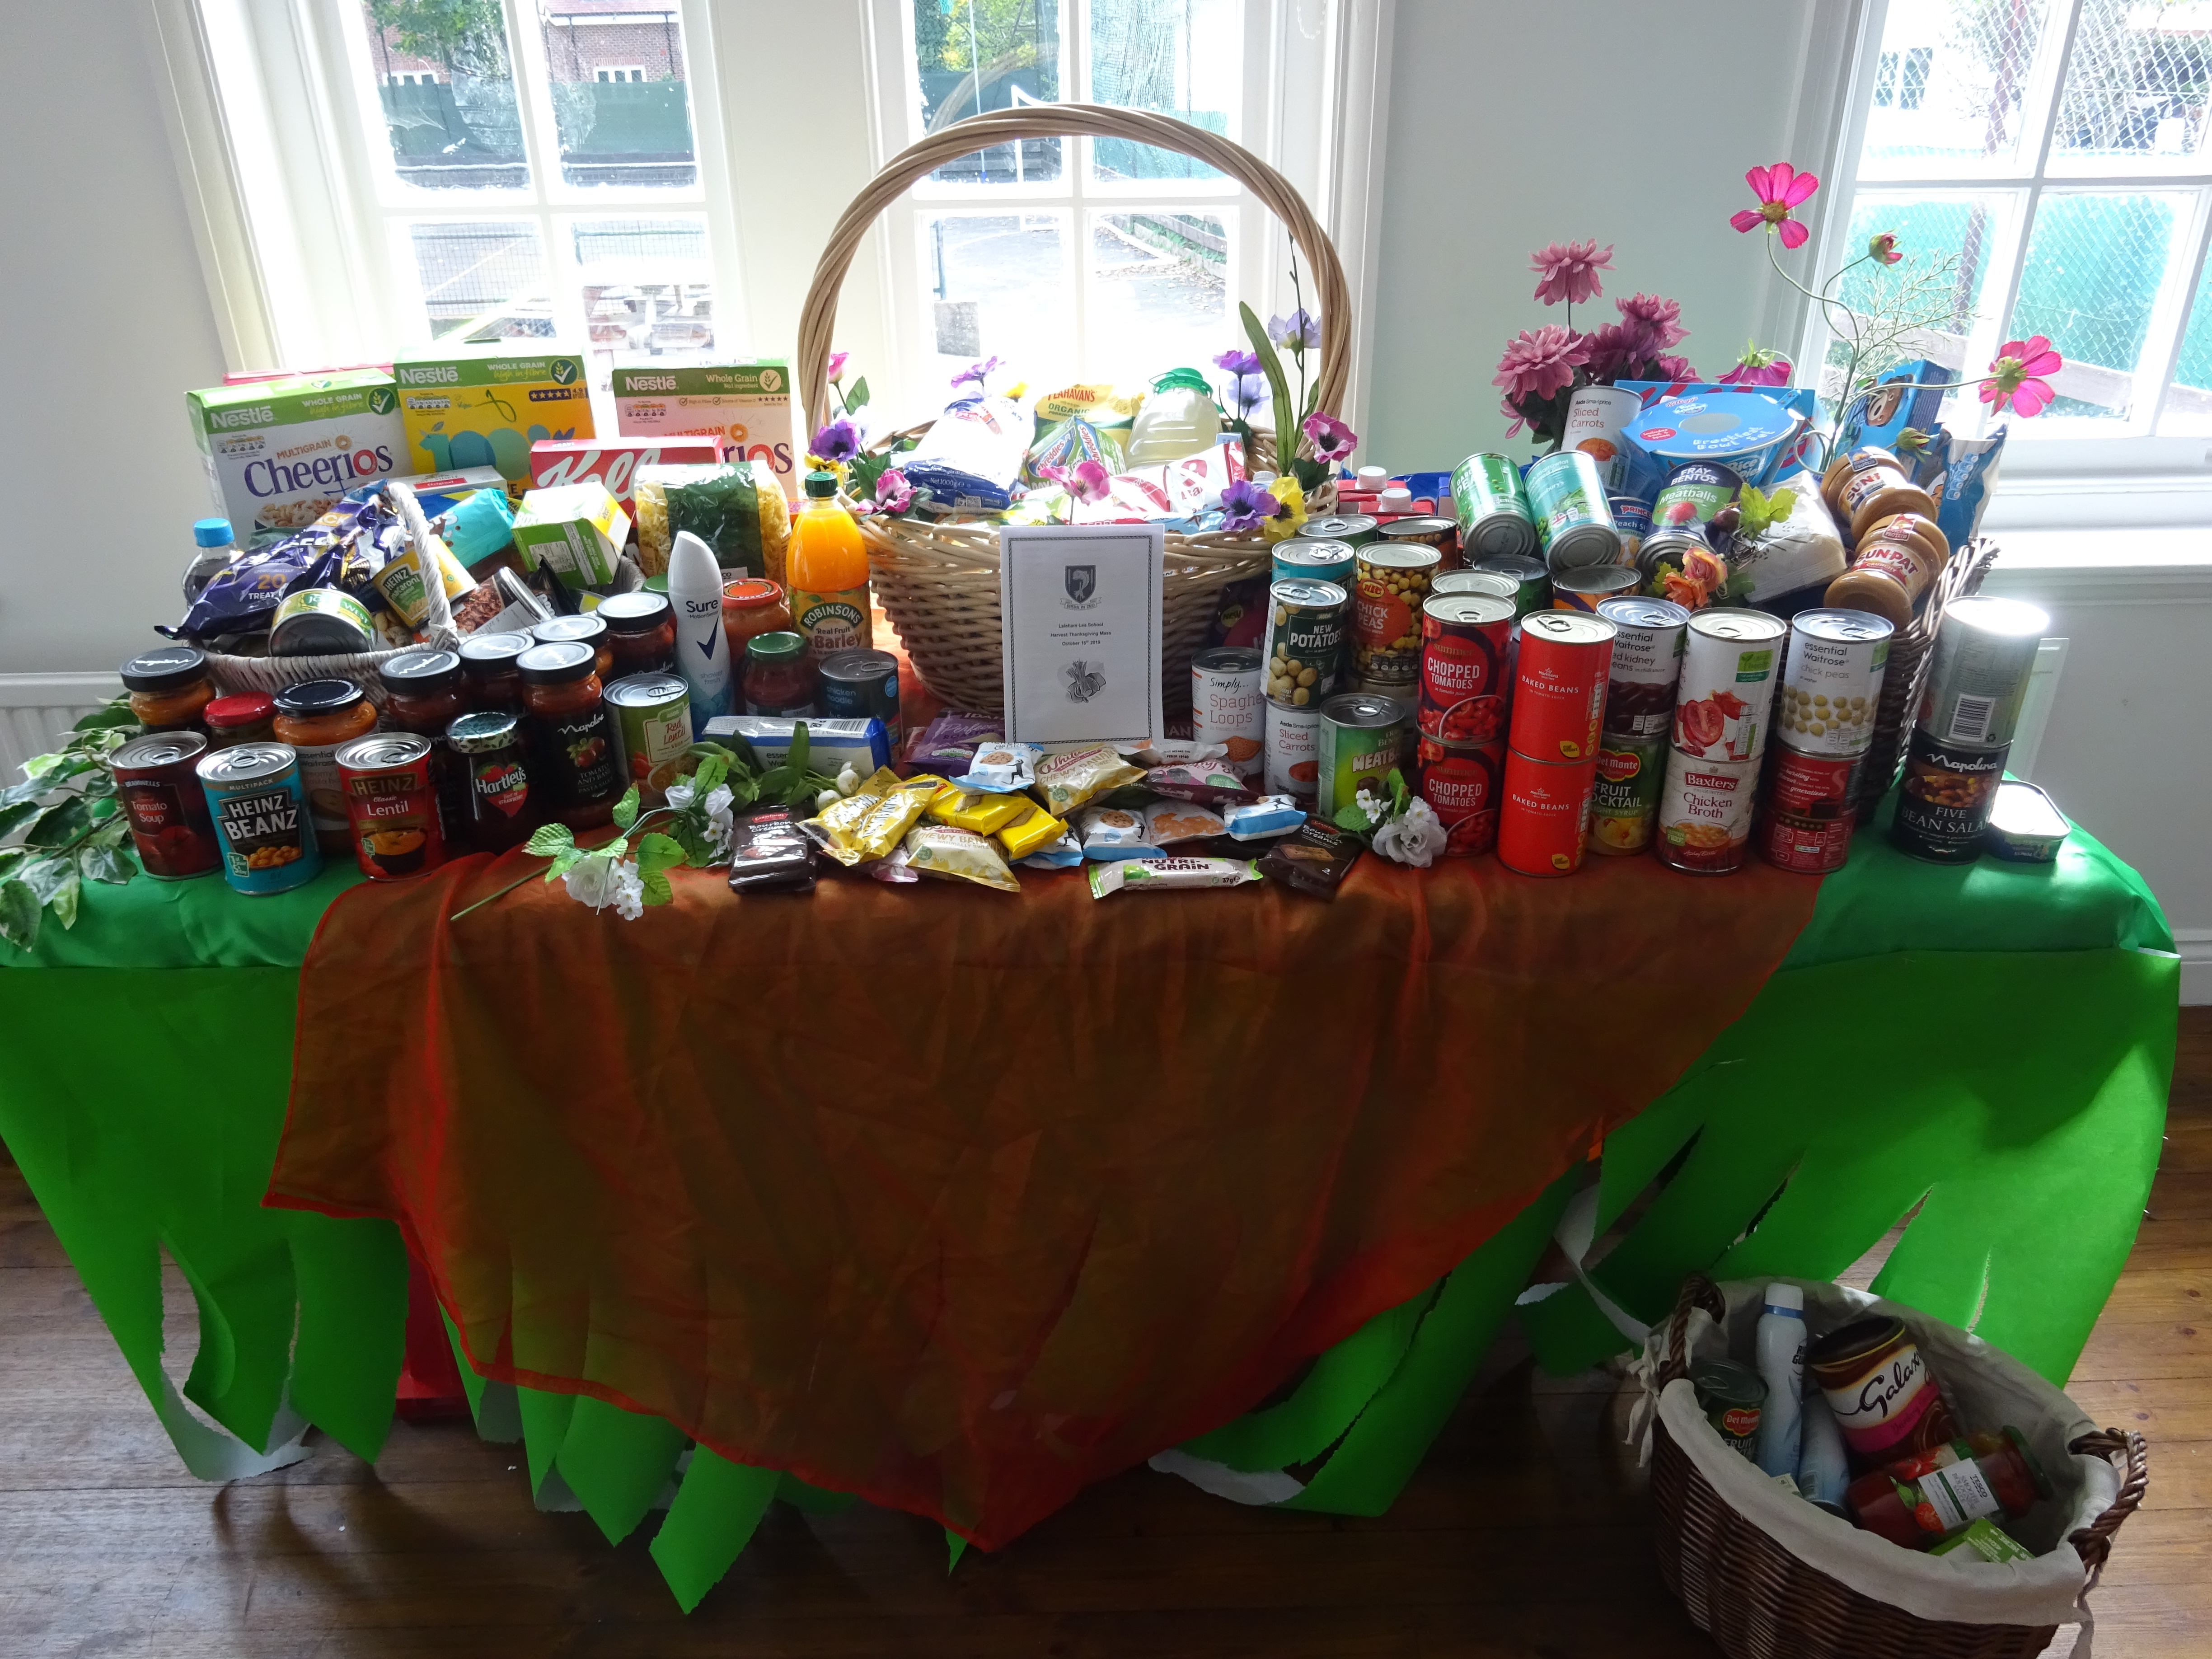
Laleham Lea School Pupils Support Purley Food Hub
Laleham Lea School in Purley dropped off their Harvest Festival collection at Purley Food Hub this week to help support families in crisis.
Over 200 items including pasta, tinned vegetables, baby wipes and deodorant were donated by Laleham Lea families to the charity who are urgently requesting donations in the run up to the Christmas period.
Helen Harris, Chair of Purley Food Hub’s Management Committee, said: “We are so grateful to the Pupils, Parents and Staff at Laleham Lea for supporting us with their Harvest Festival collection.
“It is only thanks to the generosity of schools like Laleham Lea, together with churches and other organisations that we can provide so many meals to local people going through a time of crisis.”
Ms Barry, Head teacher at Laleham Lea said: “We are delighted to be able to help the Food Hub with our Harvest Donation once again this year and I would like to thank all our families and staff for their generosity.
“Our children are always keen to help those in need and we hope that this donation helps in some small way to support the fantastic work that the Food Hub does for the local community.”

For more information please contact:
Carly Edwards
Laleham Lea School
29 Peaks Hill
Purley
CR8 3JJ
secretary@lalehamlea.co.uk
Tel:0208 660 3351

About Laleham Lea School
Laleham Lea is a Catholic Independent Primary School situated in Purley, Surrey providing education for boys and girls aged 3 to 11 years. The school aims to provide a broad, balanced and challenging curriculum within a happy learning environment. The majority of pupils are Catholic, but we warmly welcome children of all faiths who are sympathetic to our ethos.
For admissions enquiries, please contact: 0208 660 3351.

About Purley Food Hub
Purley Food Hub was set up in January 2013 by the 12 churches of Purley & Kenley Churches Together. We became a registered charity with elected Trustees in 2014. We are a member of the Croydon Food Network. We help people in crisis who are without food. Our clients may have become unemployed, are suffering illness or had a sudden, unexpected change in their circumstances at home. They may have had their benefits stopped and are going through the appeal process. A series of events coming together may have left them unable to buy food for their basic needs. We provide a balanced diet of long life food for our clients to use to prepare meals at home. We also seek to direct our clients to agencies which can give them further practical help. www.purleyfoodhub.net

