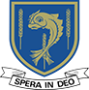
LALEHAM LEA
A Catholic Independent Primary School for boys and girls aged 3 to 11
November 23rd 2020
For immediate release
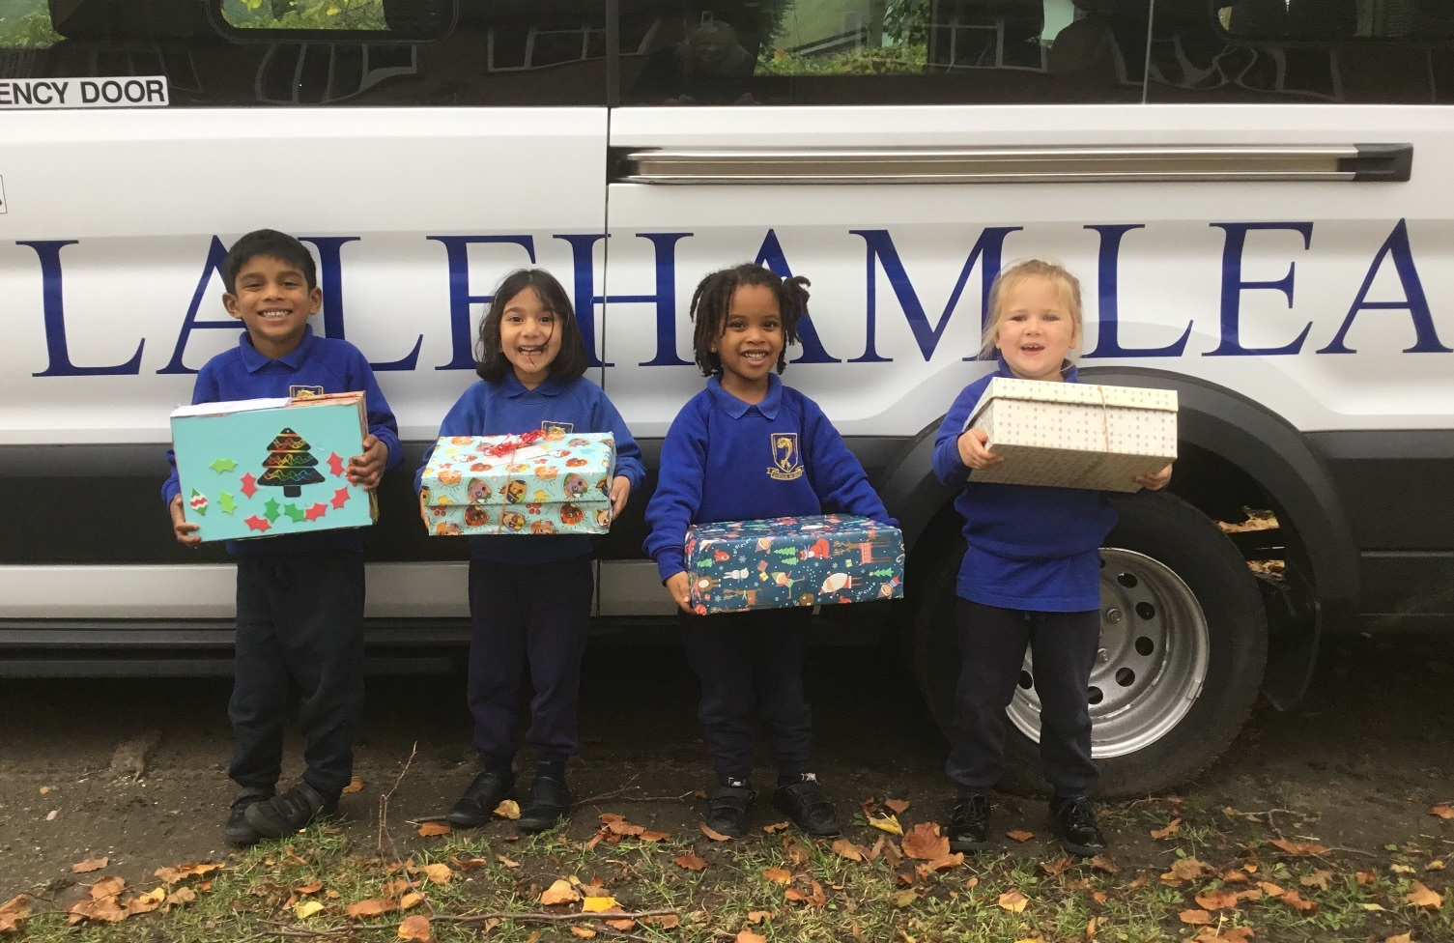
Laleham Lea School Pupils Support Samaritans’ Purse ‘Operation Christmas Child’
Pupils from Laleham Lea School in Purley have lovingly filled over 60 shoe boxes with gifts and treats for those in need around the world this Christmas.
The boxes have been donated to Operation Christmas Child, a project run by international Christian relief organization the Samaritan's Purse.
Since 1990, more than 178 million children in more than 150 countries have received an Operation Christmas Child shoebox. For many of these children, the gift‑filled shoebox is the first gift they have ever received.
Ms Barry, Head teacher at Laleham Lea said: “Laleham Lea Students and their families are always very generous throughout the year in supporting and giving to those in need.”
“We are delighted to once again support Operation Christmas Child this year; I know the Students have enjoyed filling and wrapping their special gifts with care and love. Some Students have even brought in two or three boxes! We hope they make for a lovely surprise Christmas gift for those children who really need it.”
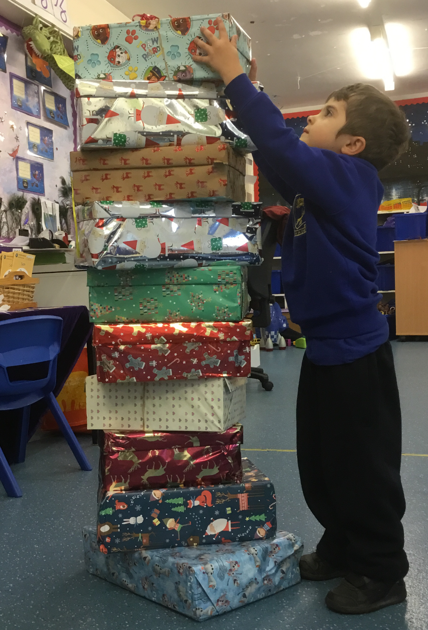
For more information or images please contact:
Carly Edwards
Laleham Lea School
29 Peaks Hill
Purley
CR8 3JJ
secretary@lalehamlea.co.uk
Tel:0208 660 3351

About Laleham Lea School
Laleham Lea is a Catholic Independent Primary School situated in Purley, Surrey providing education for boys and girls aged 3 to 11 years. The school aims to provide a broad, balanced and challenging curriculum within a happy learning environment. The majority of pupils are Catholic, but we warmly welcome children of all faiths who are sympathetic to our ethos.
For admissions enquiries, please contact: 0208 660 3351.

About Samaritans’ Purse
To learn more about Samaritans’ Purse and ‘Operation Christmas Child Visit: samaritanspurse.org/occ.

