**A Brief History of Laleham Lea School**

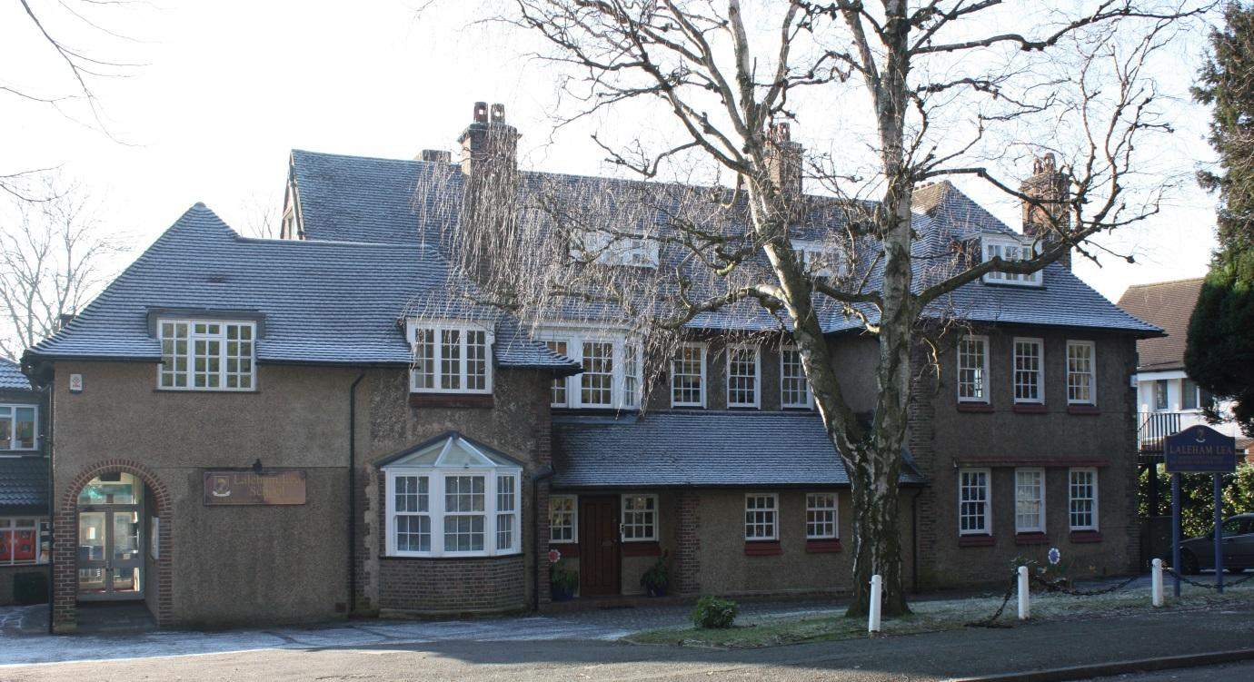

Laleham Lea is one of several small, private schools which opened in the district at the start of the 20th Century. Until World War II it was a thriving, well run preparatory school for boys and girls with high standards. During 1940 the numbers dropped to just seven pupils but the two principals, Miss Harrison and Miss Sargent, continued their work, making few concessions to the Blitz. The school continued to prosper after the war and in 1955 they purchased 'Greenhayes', the house next door. The proprietors retired in 1963 and sold the building to The John Fisher School across the road, which was an independent Catholic grammar school for boys at that time.

The school building housed the John Fisher Preparatory Department for boys from the ages of 7 to 11 years. In the early 1970's a block of four classrooms was built between the two buildings. Soon after this the three properties were linked by a connecting corridor. An Infant Department was subsequently opened and boys were then accepted from the age of 5 years.

In 1977 John Fisher became a voluntary-aided Catholic boys’ comprehensive school within the state education system. It had to cut its links with the Preparatory Department which took on a separate legal persona and revived the Laleham Lea name. However, despite this separation, Laleham Lea still has close ties with the John Fisher School. In September 1991 the School opened a Nursery and became co-educational.

The school continues as a thriving Diocesan independent Catholic school and the buildings remain the property of the Archdiocese of Southwark. Laleham Lea inspires great loyalty from former pupils and their families; one of its seven wartime pupils was Chair of Governors. Parents of children who attended the school have subsequently become Governors and Teachers. The School is very much a family school with a strong Catholic ethos and the quality of the pupils’ academic and other achievements is excellent.